Project Report

Thrift­ Fashion

Contents

1. **Details of students** ........................................................................................................
2. **Project Details**

.........................................................................................................

1. **Requirement Analysis**

..........................................................................................................

1. **Design Phase**

..........................................................................................................

1. **Source Code** ..........................................................................................................
2. **User Guide** .............................................................................................................

# 1. Details of students

|  |  |
| --- | --- |
| **Team** **Members** | **Roles** **&** **Responsibilities** |
| 1-Adnan | UI Designing |
| 2-Moiz | UI Designing |
| 3-Fahad | Json Data Storing And Javascript­ Functionality |
| 4-Areeba | Cards And Documentation |
| 5-Sobia | Cards And Documentation |

# 2. Project Details

## 

## The project is about a website titled Thrift Fashion Store, that help individuals with online shopping for second hand fashionable garments at affordable prices.

## The aim is recycling, sustainability, and reuse old clothes for people who can’t afford them and also to support a better planet.

# 3. Requirement Analysis

## Following are the functional requirements of the portal:

## Home Page

## It will display menus such as Products, About Us, Contact Us,

## Feedback, and so on. A few featured products displayed with images and

## captions will be displayed on the home page. The home page should accept first

## name from the user and display a personalized welcome message. At the top

## corner, the user's first name should be displayed for the entire duration that the

## portal is loaded.

## Products:

## This option will showcase the products one can order online via

## Thrift Fashion Store. Products can be displayed through an image gallery and

## can have product information such as availability, stock, price, discount (if any),

## product description, and so on.

## Find Product:

## Using this option, users can search for a specific product that

## they are looking out for/of their interest.

## Checkout:

## This should show the shopping cart contents and total bill based on

## product price and quantity of products purchased. You need not implement

## payment functionality; just list the cart contents and compute the bill.

## About Us and Contact Us:

## This menu option should display Email id, address,

## and contact number of the organization who is developing the system. This acts

## like the Customer Care service, which is available 24/7 to the users in case of

## any query

Over and above this, the portal should implement the following functionalities:

Functional Requirements

• Display a continuous scrolling ticker at the bottom of the page with current date,

time, and location (hint: Use geolocation features of HTML5).

• Display a visitor count at the top right corner of the page beside a logo image.

• The menu options should change color on hover and also after clicking.

Fade in and fade out options can be used for the menus.

Non-Functional Requirements

There are several non-functional requirements that should be fulfilled by the system.

The system should be:

Safe to use: The system should not result in any malicious downloads or unnecessary

file downloads.

Accessible: The system should have clear and legible fonts, user-interface elements,

and navigation elements.

User-friendly: The system should be easy to navigate with clear products/items and

other elements and easy to understand.

Operability: The system should operate in a reliably efficient manner.

Performance: The system should demonstrate high value of performance through

speed and throughput. In simple terms, the system should be fast to load and page

redirection should be smooth.

Capacity: The system should support large number of users.

Availability: The system should be available 24/7 with minimum down time.

Compatibility: The system should be compatible with latest browsers.

|  |
| --- |
| **4. Design Phase** |

|  |
| --- |
| **5. Source Code** |

|  |
| --- |
| **6. User Guide** |

1. **System Requirements:**

* + Android Supporting Smart Phone
  + Required Android Version Minimum 5.1 Lollipop-Maximum 7.0 Nougat
  + Required Internet

1. **Install and Run Application:**

* Download Application from Google play Store and Install Application.

***SOURCE CODE***

**HOME PAGE**

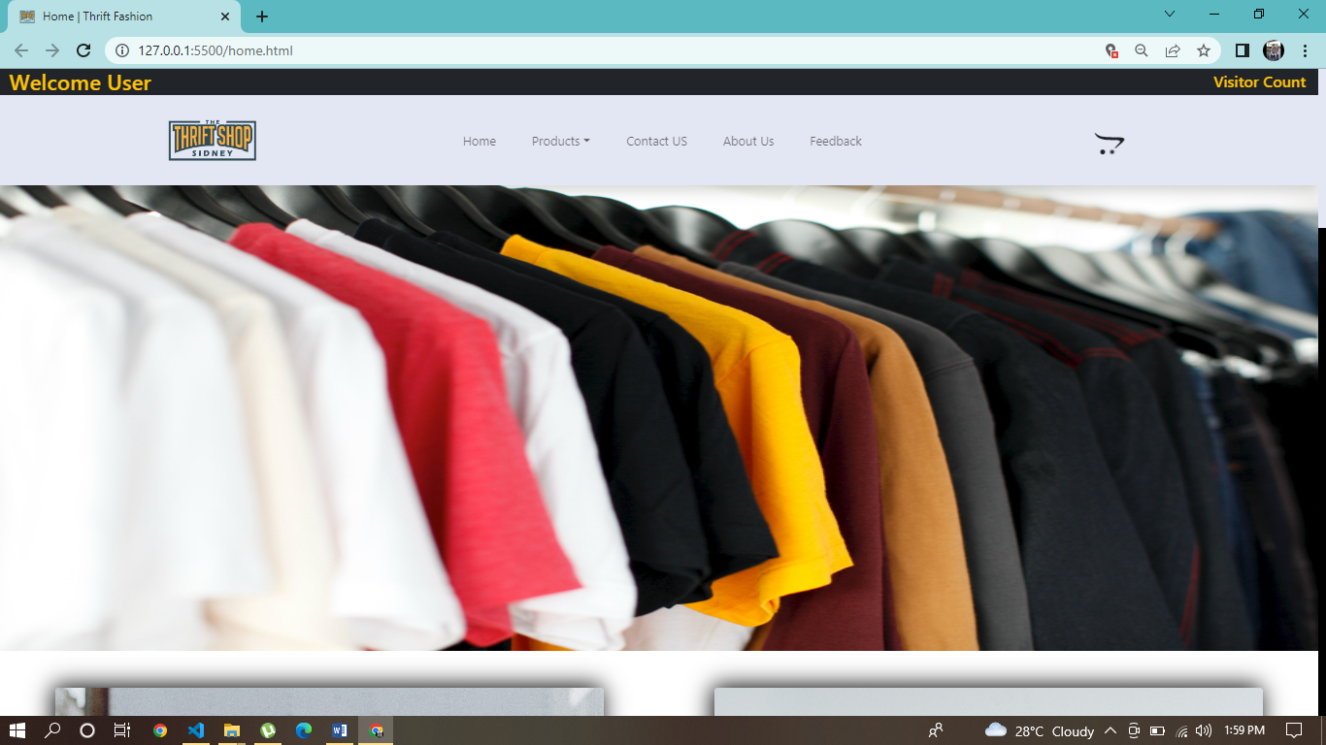

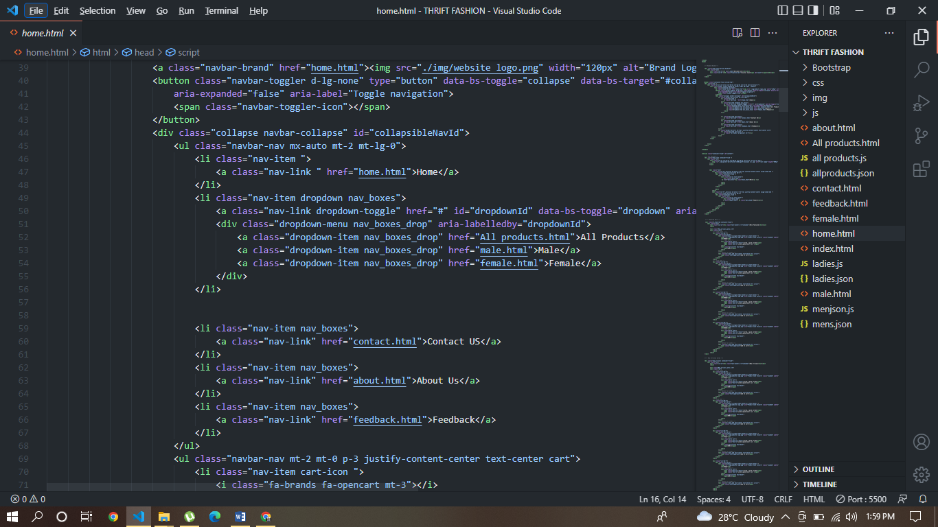

**FEATURES**

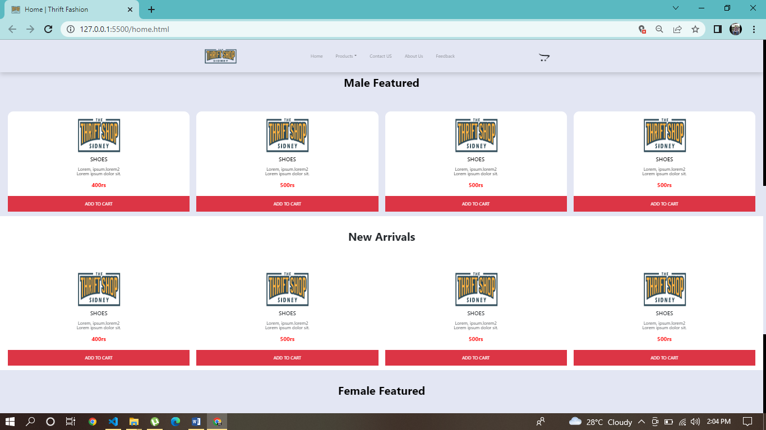

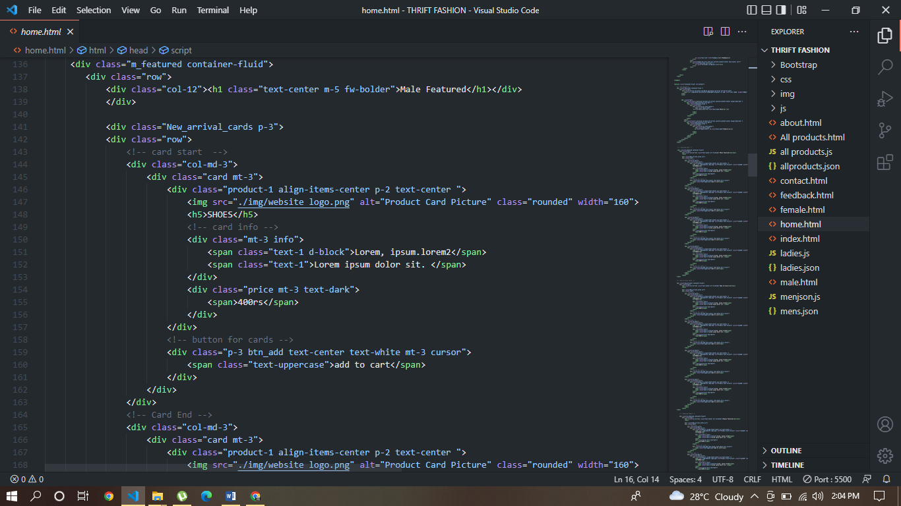

**PRODUCTS**

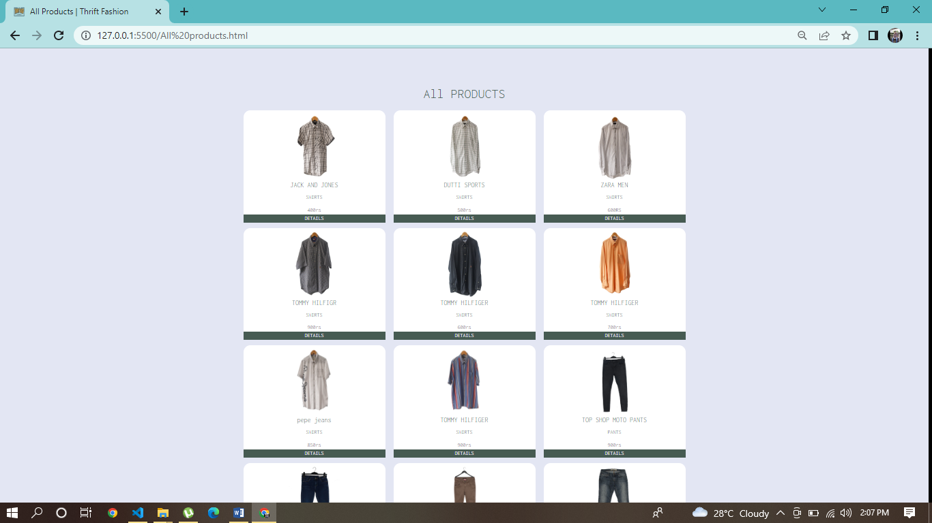

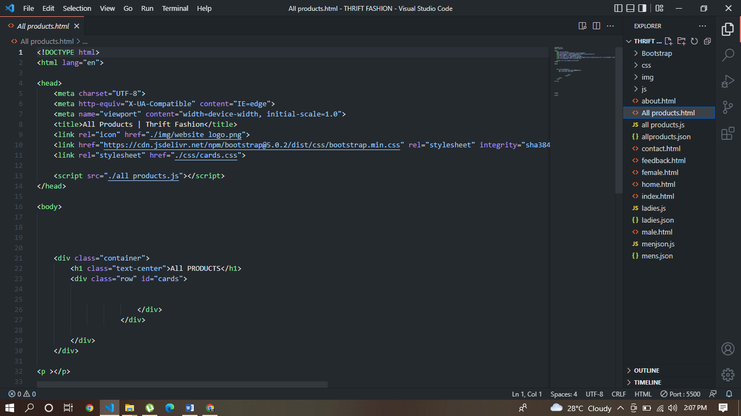

**CONTACT US**

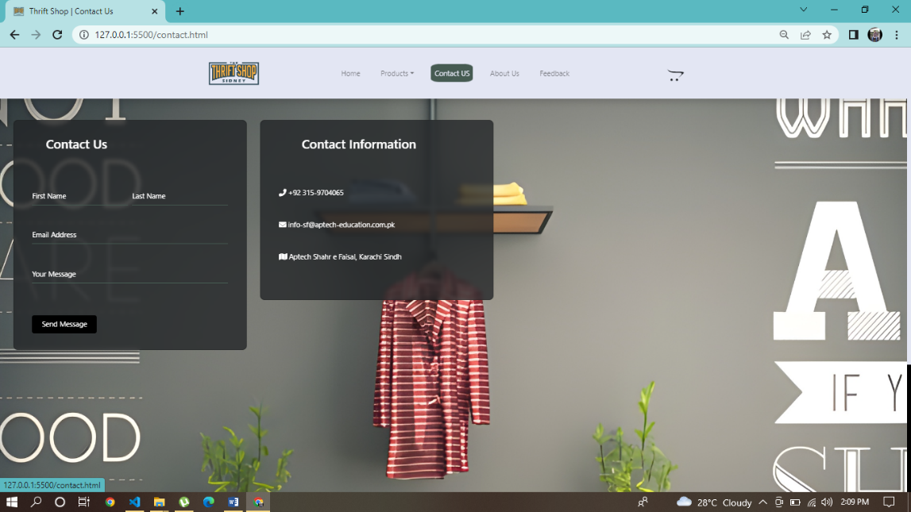

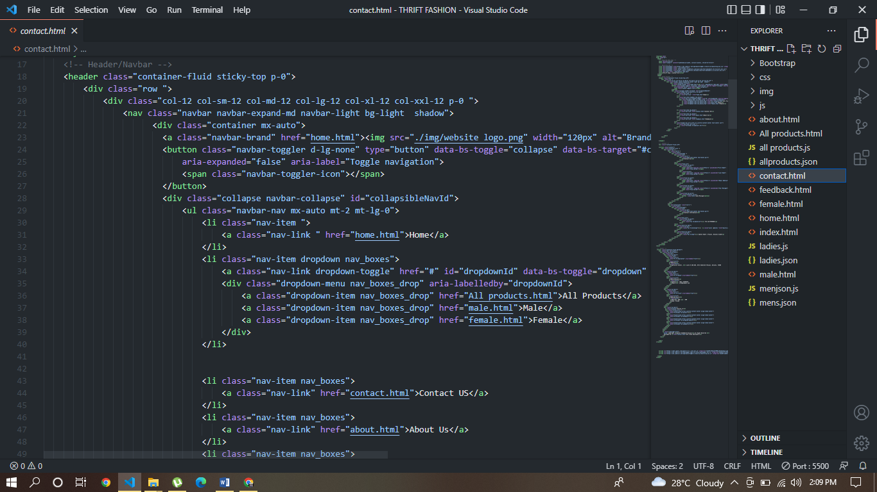

**ABOUT US**

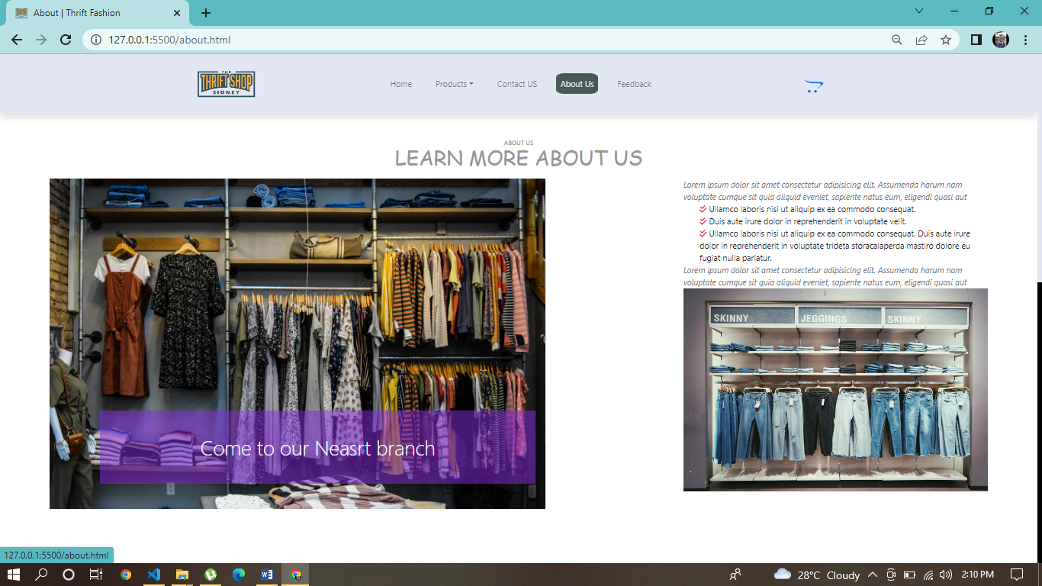

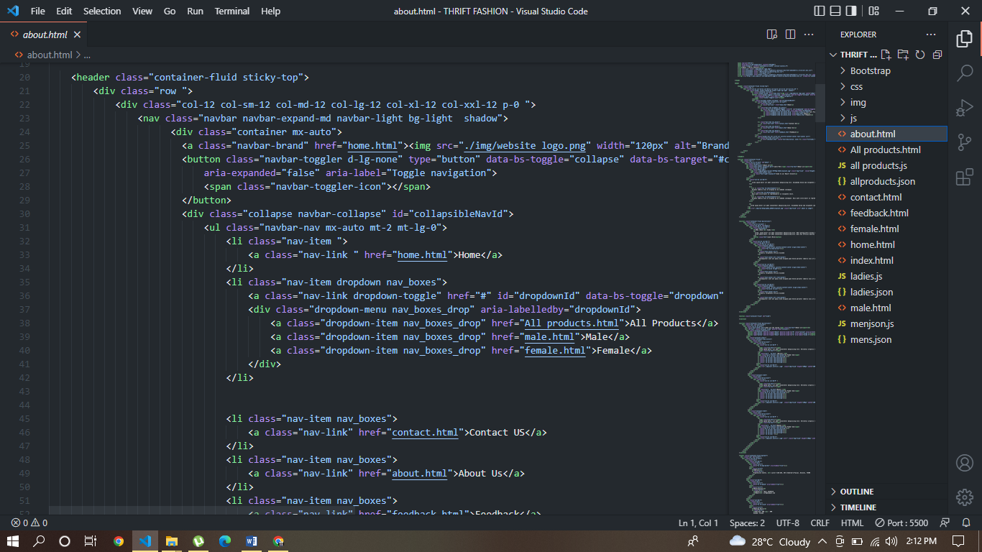

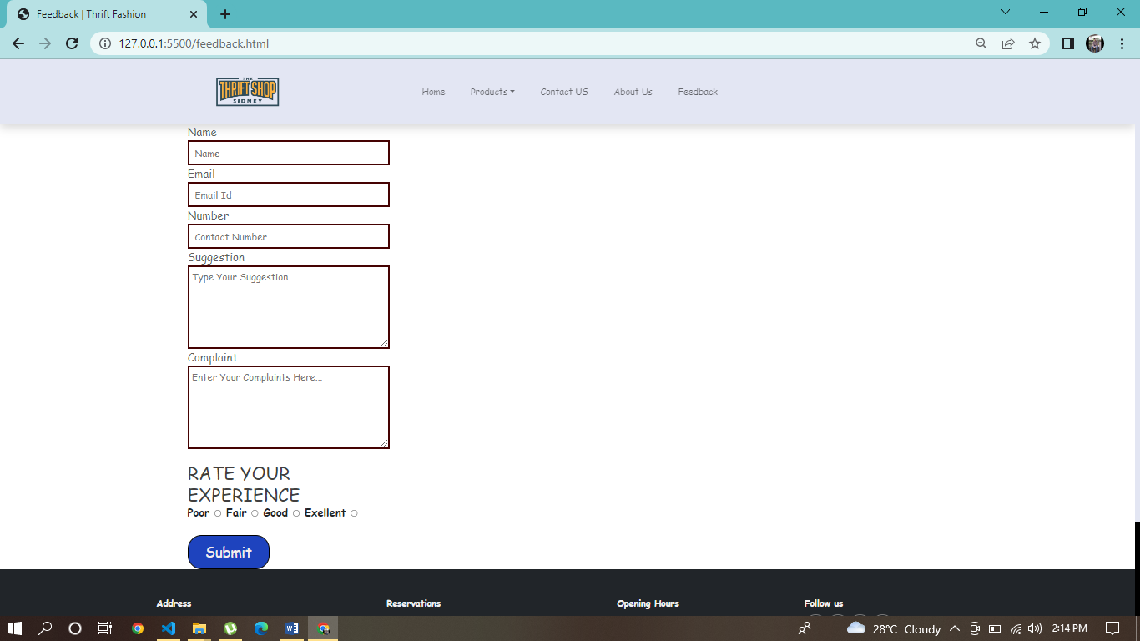 **FEEDBACK**